Hardware-Efficient CNN Accelerator Supporting Standard and Depthwise Convolution with Integrated ReLU and Max-Pooling

- Key Features of the Proposed CNN Accelerator:

1.0 Efficient 3D Convolution Engine
The proposed design implements a high-performance 3D convolution engine capable of performing convolution operations across multiple input and output feature maps simultaneously.
This architecture maximizes computational efficiency by exploiting spatial and channel-level parallelism within convolution layers.

2.0 Support for Multiple Convolution Types
The engine supports both standard convolution and depthwise convolution operations, providing architectural flexibility to accommodate a wide range of CNN models.
This adaptability enables efficient mapping of diverse convolutional workloads onto a unified hardware platform.

3.0 Pipelined MAC Architecture
A deeply pipelined Multiply–Accumulate (MAC) architecture is employed to enhance computational throughput.
This design allows multiple MAC operations to be executed concurrently, thereby achieving low-latency processing and high throughput across convolutional layers.

4.0 Integrated Activation Function
The Rectified Linear Unit (ReLU) activation function is tightly integrated within the computational pipeline, enabling non-linear feature extraction to occur directly in hardware.
This integration eliminates additional processing stages and reduces overall latency.

5.0 On-Chip Pooling Module
An on-chip pooling module is incorporated to perform max-pooling operations, facilitating spatial feature reduction while enhancing memory efficiency.
The pooling block supports configurable kernel sizes, allowing adaptability across different CNN architectures.

6.0 BRAM-Based Memory Management
The design leverages on-chip Block RAM (BRAM) for data reuse, intermediate storage, and buffering of input/output feature maps.
This approach minimizes off-chip memory access, thereby reducing latency and power consumption while improving overall system efficiency.

7.0 Scalable and Configurable Architecture
The convolution engine is scalable and parameterizable, supporting high-dimensional image data and multiple CNN configurations.
Its modular structure allows easy adaptation to varying layer dimensions, kernel sizes, and channel counts with minimal hardware overhead.

2.0 Key Capabilities and Design Highlights

2.1 Parameterized Design
The architecture is fully parameterized, supporting configurable parameters such as image size (n×n), kernel size (k, default = 3), input channels (ch), number of filters (fi), and memory address width (MA, default = 18).
This flexibility enables seamless adaptation to diverse convolutional neural network (CNN) configurations.

2.2 32-bit Signed Datapath
All pixel, weight, and accumulation values utilize a 32-bit signed datapath, ensuring precise arithmetic computation and maintaining numerical stability during convolution and pooling operations.

2.3 Memory Interface
A dual-port Block RAM (bram_dual_port1) is employed for parallel image and kernel data reads and pooled output writes.
This configuration enhances memory bandwidth and reduces latency during high-throughput data transfers.

2.4 Dedicated 3×3 MAC Core
A specialized 3×3 Multiply–Accumulate (MAC) core (mac9) is integrated to perform patch-level convolution with preloaded kernel weights.
This core efficiently computes localized feature extraction operations within each receptive field.

2.5 Index Generation and Line Buffering
An index generation unit (shift_index_generator) dynamically produces 3×3 convolution window indices, while the line buffer stores intermediate image rows to enable sliding-window operations.
This approach significantly reduces external memory traffic and improves data reuse efficiency.

2.6 Nonlinear Activation and Pooling
The engine integrates ReLU activation for non-linear feature mapping, followed by a 2×2 max-pooling module (max_pool4).
Dedicated address and index generators support efficient spatial reduction and hierarchical feature extraction.

2.7 Multi-Channel and Filter Flow Management
A centralized Finite State Machine (FSM) coordinates the iterative processing of multiple input channels and filters, manages accumulation across channels, and generates layer completion flags for precise control and synchronization.

2.8 Synthesis Directives
Synthesis attributes such as
(* ram_style = "block", keep_hierarchy = "yes" *)
are incorporated to ensure efficient BRAM inference, preserve module hierarchy, and enhance timing optimization during FPGA synthesis.

2.1.Control Flow (FSM Overview)
- s0 – Kernel Load: Stream kernel to karnel_matrix.
- s1 – Convolution: Load image pixels → line buffer → MAC9 → write conv outputs.
- s2 – Channel Update: Adjust addresses for next channel/filter.
- s3 – BRAM Align.
- s4 – ReLU + Pool: Apply ReLU, 2×2 max-pool, store outputs.
- s5/s6 – Filter Iteration: Repeat for all filters.
- s7 – Done/Idle.

2.2.Dataflow & Memory Mapping
- Latency Compensation: FSM accounts for MAC pipeline (~4 cycles).
- Dual-port BRAM: Port A for reads, Port B for pooled writes.
- Streaming Compute: Single mac9 reused for all patches (area-efficient).
- Memory Layout:
  - Image/kernel stored as contiguous words.
  - Kernel: k×k 32-bit values.
  - Pooled results start at maxpool_store_addre

For better understanding purpose image is taken from online so:
Image:7*7*4
Ch_NO: 4
Filter:3*3*4
Crossponding CoN layer
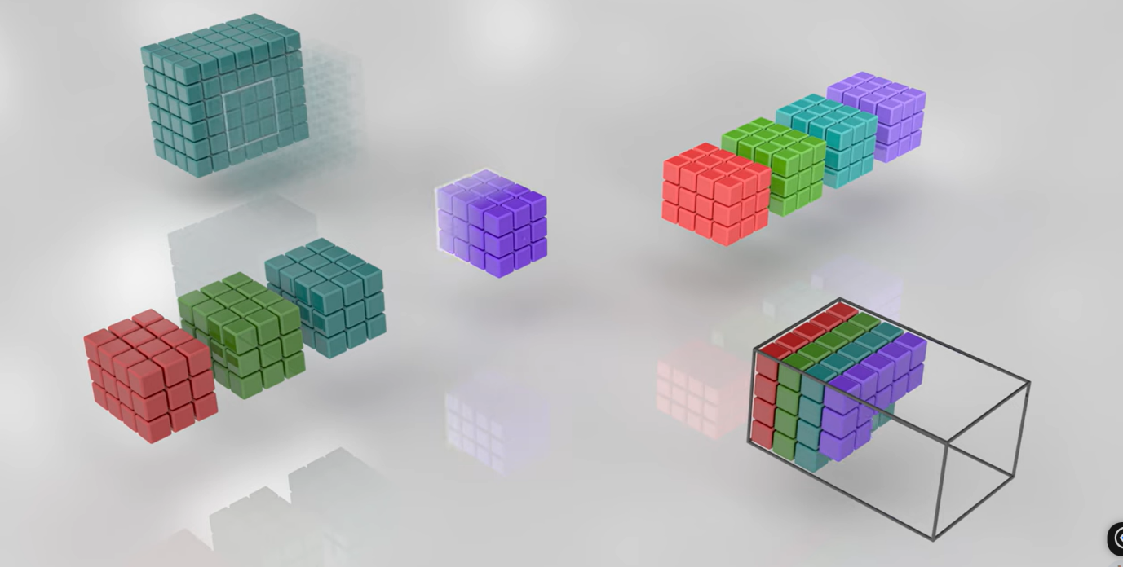

Core_Logic:
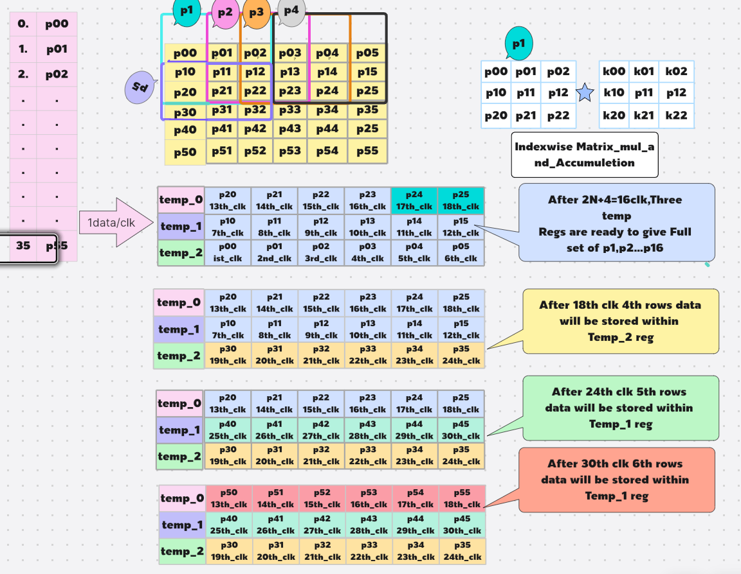
BRAM
Kernel 3*3

Example:

6×6 Image Convolution Dataflow Description:

3.0 Dataflow and Convolution Mechanism:

3.1 Input Image Storage
The proposed architecture considers a 6×66 \times 66×6 input image matrix (used here for algorithmic illustration), consisting of a total of 36 pixels. All pixel data are preloaded into the on-chip memory (RAM) to ensure low-latency access and eliminate frequent external memory transactions during convolution operations.

3.2 Pixel Fetching Mechanism
A single-pixel fetch policy is implemented, wherein one pixel is retrieved from memory per clock cycle. The fetched pixel is temporarily stored within a register array (temp_reg), enabling rapid reuse of data and reducing redundant memory access during convolution.

3.3 Temporary Register Organization
Given a fixed 3×3 kernel, three temporary registers — temp_reg1, temp_reg2, and temp_reg3 — are utilized to store three consecutive rows of the input image simultaneously. This configuration facilitates efficient patch sliding, reduces memory bandwidth requirements, and improves overall dataflow efficiency.

3.4 Initial Data Loading Phase
Because the convolution kernel size is fixed at 3×3, three temporary registers are employed to buffer corresponding image rows. For an image of dimension N*N=6*6=36, the system requires 2N+4=162N + 4 = 162N+4=16 clock cycles to fully populate these registers. After this one-time initialization, all nine elements of the first 3×3 patch become available for immediate computation, ensuring a smooth transition into the convolution stage.

3.5 Patch Formation Process
After initialization, the architecture dynamically generates a new 3×3 patch during every subsequent clock cycle. This is accomplished through an internal data-shifting mechanism within the temporary registers, coupled with continuous single-pixel fetching from memory. The sliding-window strategy maintains uninterrupted dataflow and enables the convolution pipeline to operate continuously without stalls.

3.6 Convolution Operation
Each clock cycle delivers nine pixels from the current 3×3 patch to a fully pipelined Multiply–Accumulate (MAC) engine. The MAC performs convolution operations for the active patch while the next patch is concurrently prepared. As a result, pixel loading, patch formation, and convolution computation are all overlapped within the same clock cycle, ensuring high throughput and minimal latency.

3.7 Concurrent Operations per Clock Cycle
The design achieves full pipeline concurrency, executing the following three operations simultaneously during each clock cycle:
- Pixel Fetch: A new pixel is read from on-chip memory.
- Patch Generation: The 3×3 sliding window is updated via internal register shifting.
- MAC Computation: The convolution output for the current patch is computed in real-time.
This concurrent operation eliminates idle cycles, resulting in a sustained, high-efficiency computation flow.

3.8 Stride and Output Size
With a fixed stride of 1, an input size of 6×6, and a kernel size of 3×3, the output feature map dimension becomes 4×4. Accordingly, the system produces a total of 16 convolution outputs, one per clock cycle, across 16 cycles. This predictable and uniform data generation supports smooth integration with subsequent processing layers.

3.9 Output Storage and Multi-Channel Accumulation
Each convolution output is sequentially written back to the same on-chip BRAM, enabling efficient data reuse. For multi-channel convolution, once processing for one channel completes, the intermediate results remain stored in BRAM. As the next channel is processed, new convolution outputs are directly accumulated with the previously stored values at the same addresses. This in-place accumulation technique, executed concurrently with pipeline operation, significantly minimizes LUT and register utilization while maintaining high on-chip data locality and memory efficiency.

3.10 Overall Dataflow Efficiency
The proposed architecture ensures complete overlap between memory access, patch formation, and MAC computation. By leveraging deep pipelining and BRAM-based data reuse, the design eliminates latency gaps, optimizes hardware utilization, and maintains continuous data movement throughout the convolution process. The resulting implementation achieves superior processing throughput, reduced logic overhead, and scalable efficiency across multi-channel CNN configurations.

Major Achievement for Large-Scale Image Processing:

4.0 Scalability and Performance Analysis

4.1 Scalability
The proposed convolutional dataflow architecture is inherently scalable to support high-dimensional image inputs and multiple feature channels. Its modular design allows seamless expansion with respect to both image resolution and the number of concurrent processing channels, without compromising throughput or timing closure. The pipeline maintains consistent performance regardless of image dimension, making it suitable for real-time edge inference and large-scale CNN workloads.

4.2 Configuration Example
To evaluate scalability, a representative configuration is considered:
- Input Image Size: N×N*P=256×256*3 Here N*N=image_size;P=no: of channel
- Number of Parallel Channels: P=5;
This configuration demonstrates the architecture’s capability to handle high-resolution inputs while maintaining real-time throughput.

4.3 Total Processing Cycles
The complete operation — encompassing pixel fetching, standard convolution, ReLU activation, max-pooling, and output storage — is executed within:T=N×N×P+10=256×256×5+10=327,690 clock cycles
At a 100 MHz operating frequency, the total processing time corresponds to approximately 3.28 ms, highlighting the design’s suitability for high-speed image processing applications.

4.4 Clock Period and Operating Frequency
- Clock Period: 10 ns
- Operating Frequency: 100 MHz
The design achieves stable timing at this frequency while sustaining full pipeline utilization across all modules.

4.5 Performance Outcome
The architecture exhibits fully pipelined operation with complete overlap among data fetching, convolution, activation, pooling, and storage stages. This enables continuous dataflow and eliminates idle cycles, resulting in:
- Real-time processing for large-scale images
- Minimal latency per frame
- Maximized throughput utilization across all processing elements

4.6 Multi-Channel Convolution Optimization
During standard convolution, once computation for one channel is completed, the results are stored in the same on-chip BRAM. As the next channel is processed, the previously stored data are read, accumulated with the new outputs, and written back to the same memory locations. This in-place accumulation approach sustains pipeline continuity, significantly reduces LUT and register consumption, and ensures efficient resource utilization even for large multi-channel inputs.

CNN Accelerator Pipeline Flow Chart:

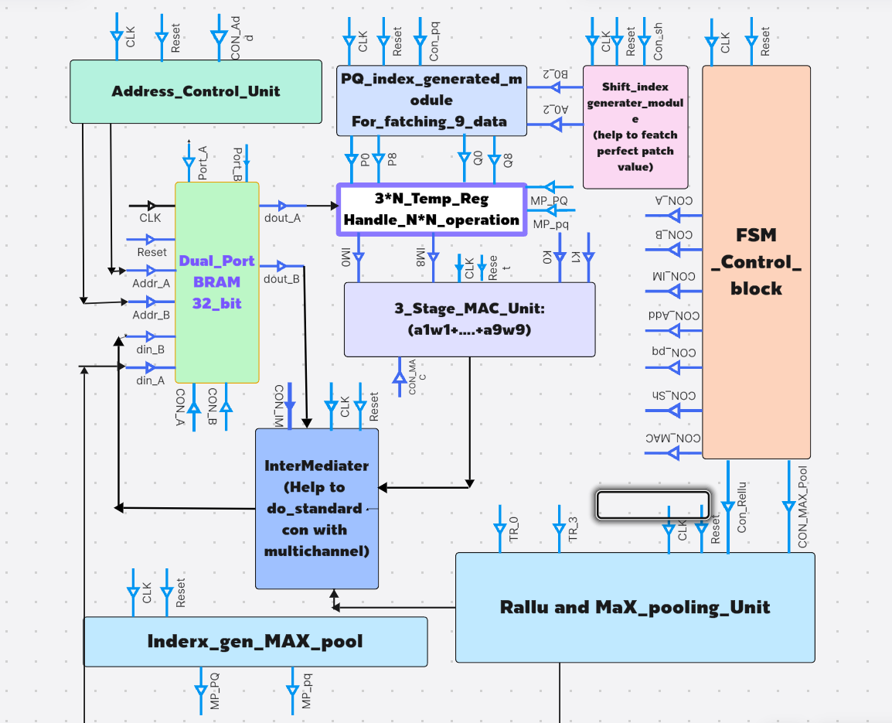

Demonstration of Convolution Operation on a 256×256×3 Image Matrix with a 3×3×3 Kernel:
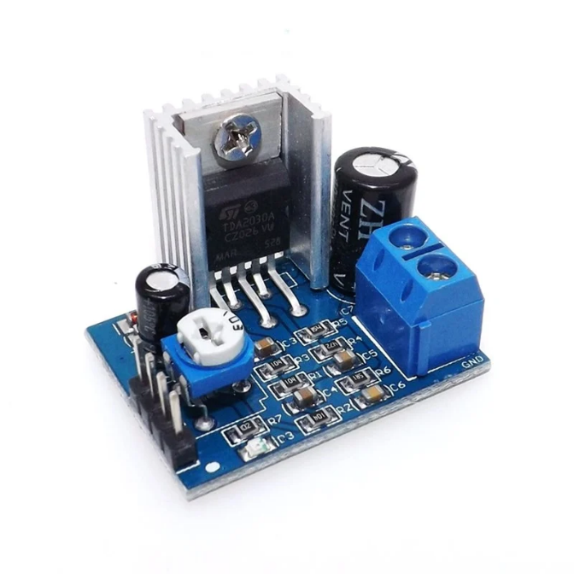
The original image has been separated into three individual channels—Channel 1 (R), Channel 2 (G), and Channel 3 (B)—each with a resolution of 256 × 256 pixels.
by using this code I have generated pixels_channelwise.txt this file .then convert into this hex file now this hex is uploaded to my CNN Accleretor(here depthwise and standard convolution possible_multichannel _multifilter possible).After simmuletion it generates this file .Again this file is uploaded into this python code.
Depthwise_Convolution
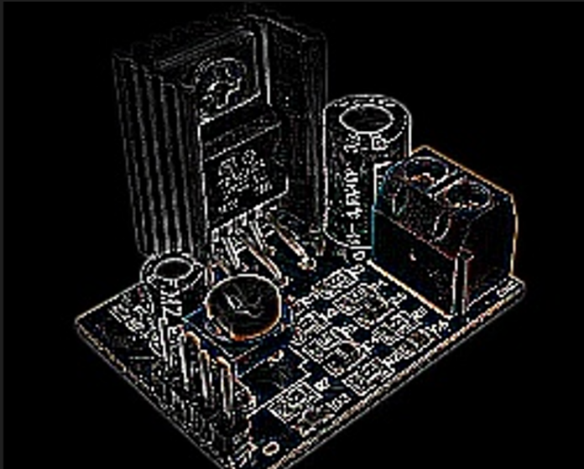

Standard_Convolution(3D) Standard_Convolution(3D)
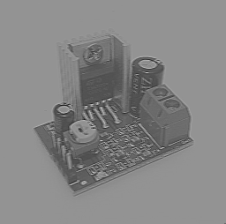
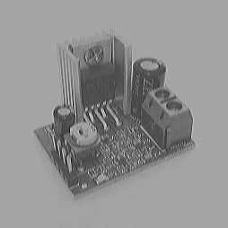

This is expected (python) Getting from CNN RLT

# Step 5: Define 3x3x3 kernel (example)
kernel = np.array([
[[0, -1, 0],
[-1, 5, -1],
[0, -1, 0]], # for Red

[[0, -1, 0],
[-1, 5, -1],
[0, -1, 0]], # for Green

[[0, -1, 0],
[-1, 5, -1],
[0, -1, 0]] # for Blue
],
Features Extraction_Filter_Mapping
This 3*3*3 kernel I had used to my CNN_Accleretor.

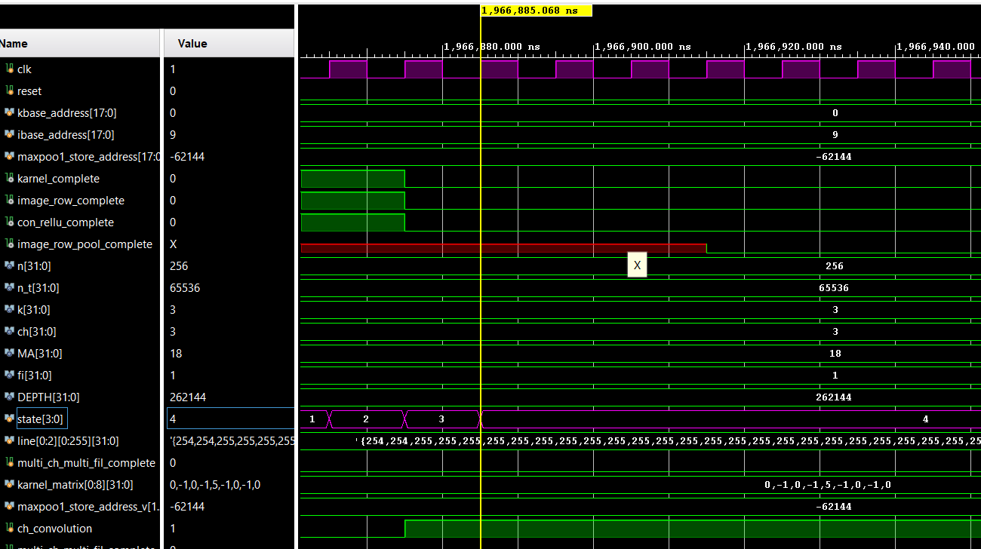
Required Clock Cycles for 256×256×3 Convolution with 3×3×3 Kernel :

According to my design when system reach to in state 4 .Standard convolution operation is just completed here we have performed 256*256*3 with karnel 3*3*3 no. of filter=1.
Required Clk=1966885*10 =1,96,6880ns=1.96msec
According to my calculation=256*256*3=1,96,608 which is relatively quiet fast.
Hardware Utilization:
For N*N*P (N*N=image size and P is number channel)
Major Hardware is Used only for Image size(N*N)but totally independent Channel No(p).
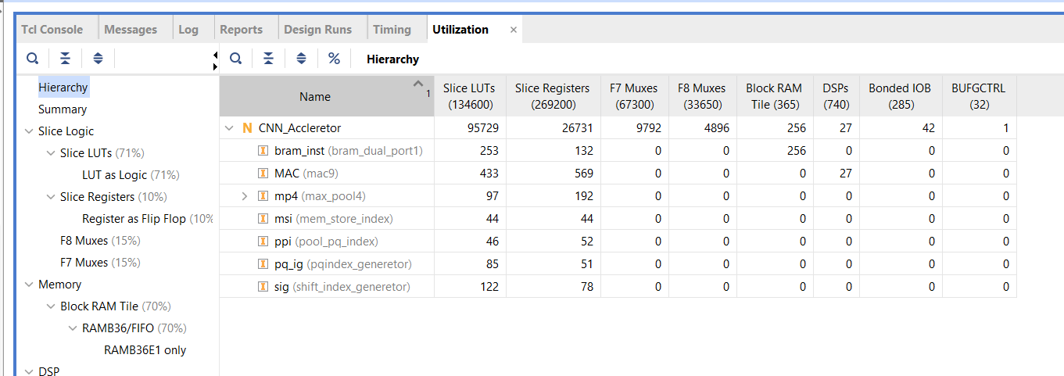
256*256*P(32_bit_pixel_size):

LUTs: 95729
FFs: 26731
BRAM: 256

256*256*P(16_bit):
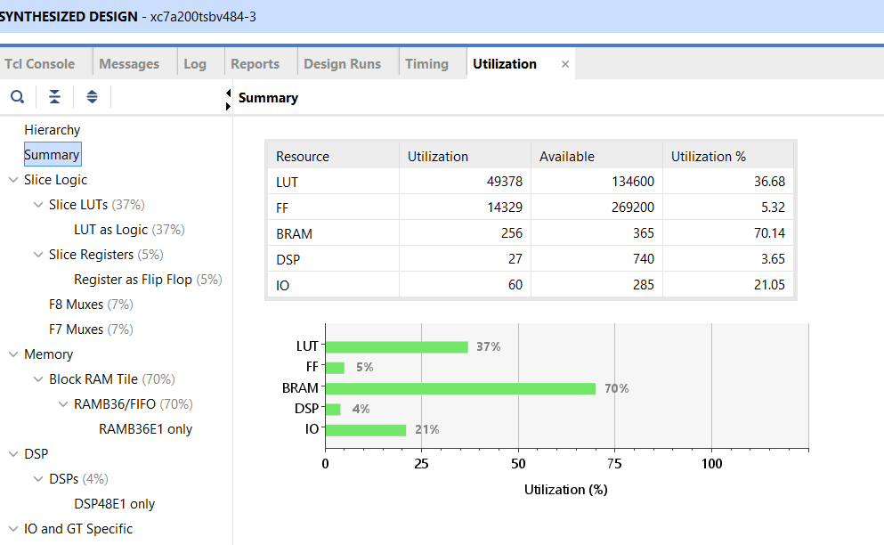

LUTs: 49378
FFs: 14546
BRAM: 256

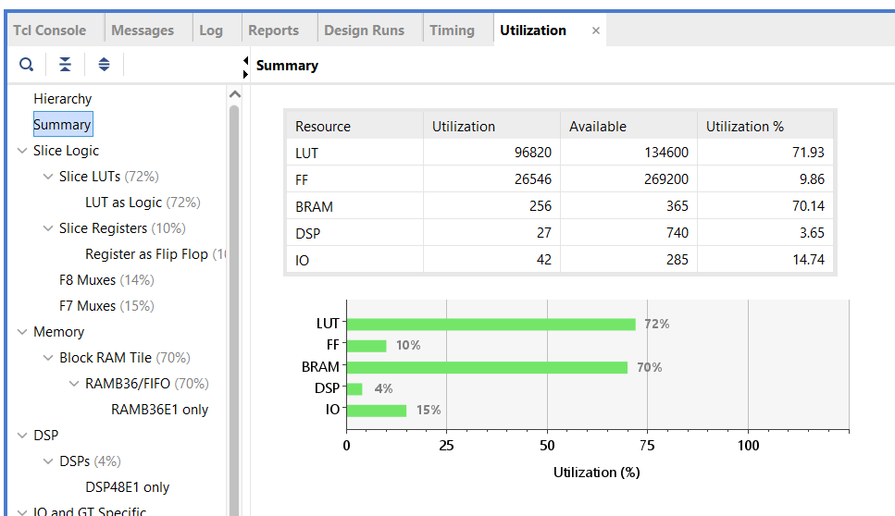
512*512*P(16_bit):

LUTs: 96820
FFs: 26546
BRAM: 256

